EXPERIMENT 4.2: SUPPORT VECTOR MACHINE (SVM) CLASSIFICATION

AIM:
To implement a Support Vector Machine (SVM) classification model to predict students' results and evaluate its performance.

ALGORITHM:
- Import Pandas and the required Scikit-learn modules.
- Load the dataset from data.csv.
- Select Hours_Studied, Attendance, and Assignments as input features.
- Select Result as the target variable.
- Split the dataset into training and testing sets in an 80:20 ratio.
- Create an SVM classifier using a linear kernel.
- Train the model using the training data.
- Predict the results for the testing data.
- Calculate and display accuracy and the confusion matrix.
- Display the classification report containing precision, recall, and F1-score.
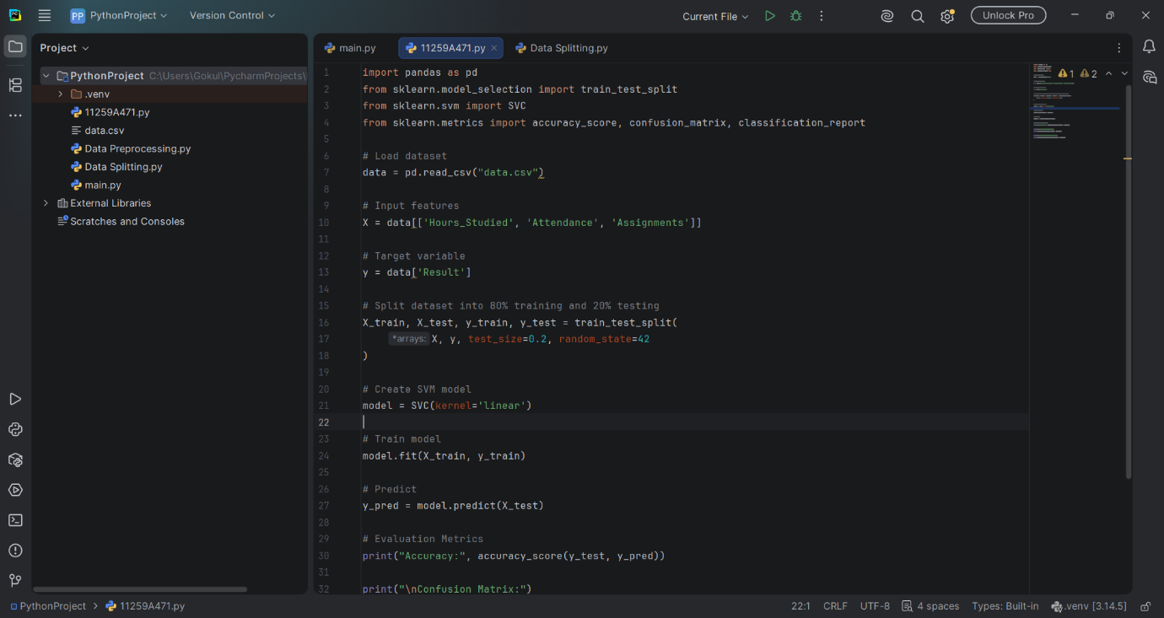

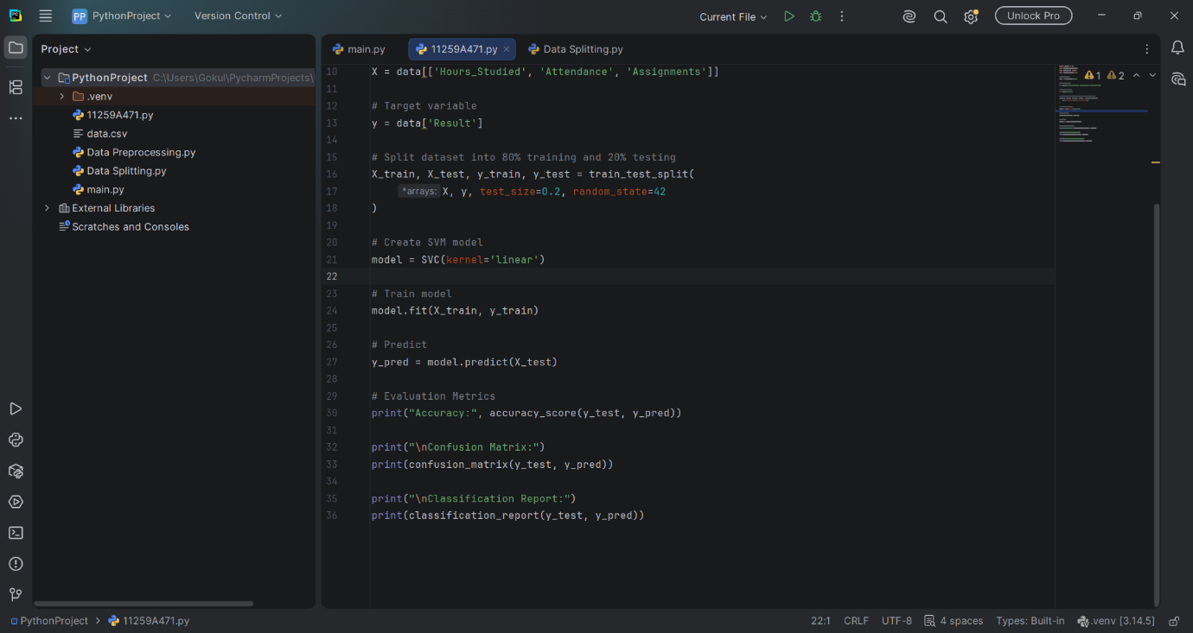
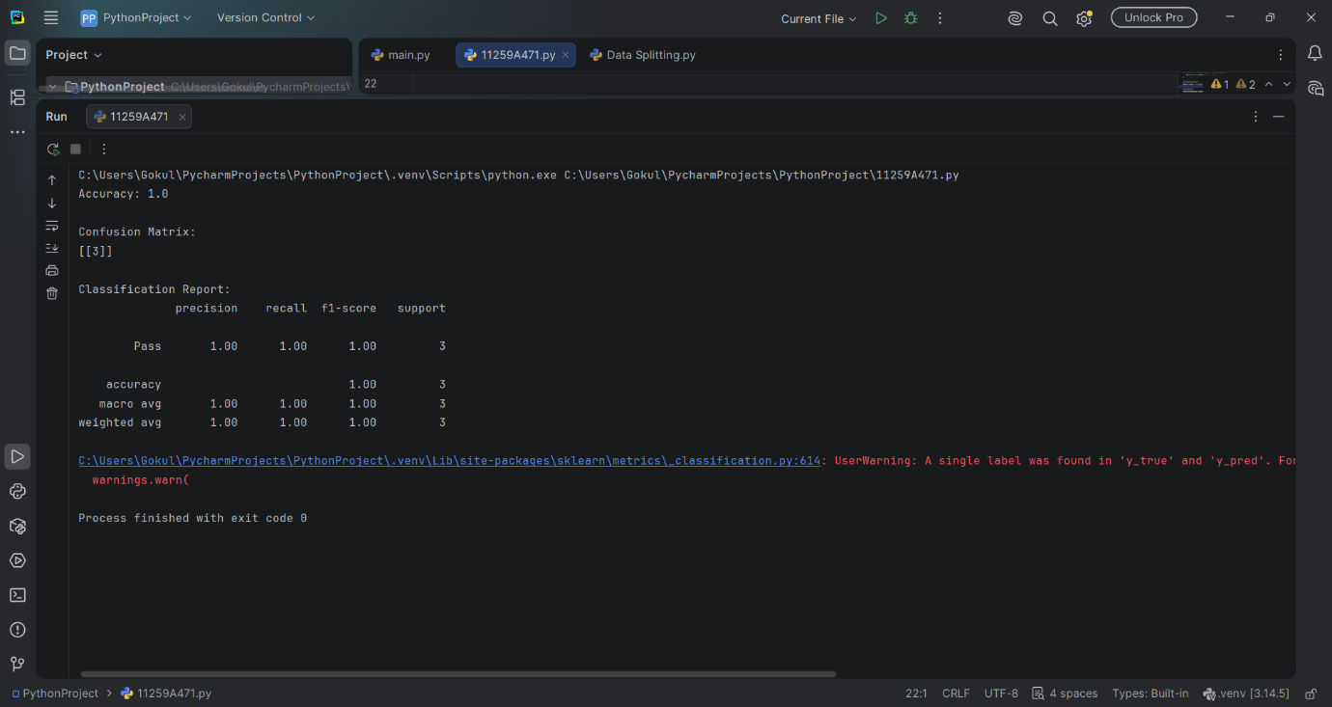

RESULT:
The SVM classification model was successfully trained and tested. Its performance was evaluated using accuracy, the confusion matrix, and the classification report.

